* User view home page.
* User see different page name (home, Gallery, Contract us, feed back & login with footer for quick access)

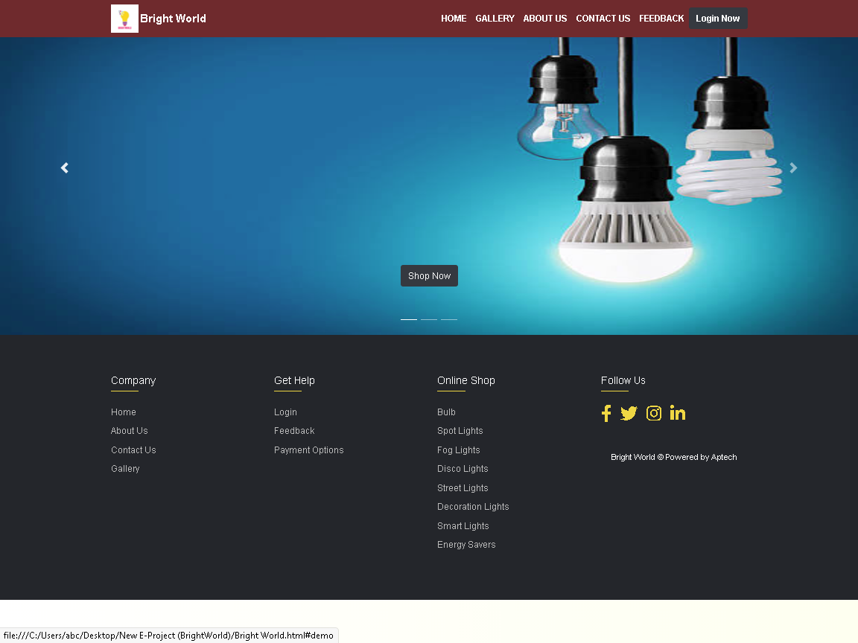

**Category Section**

* User view gallery of Categories of product.
* User can buy online product by clicking on **“Click Here”** button.
* If user want the details about the product by clicking on **“Download PDF”** button.
* User has a facility of downloading products details by clicking on **“Download PDF”** button.

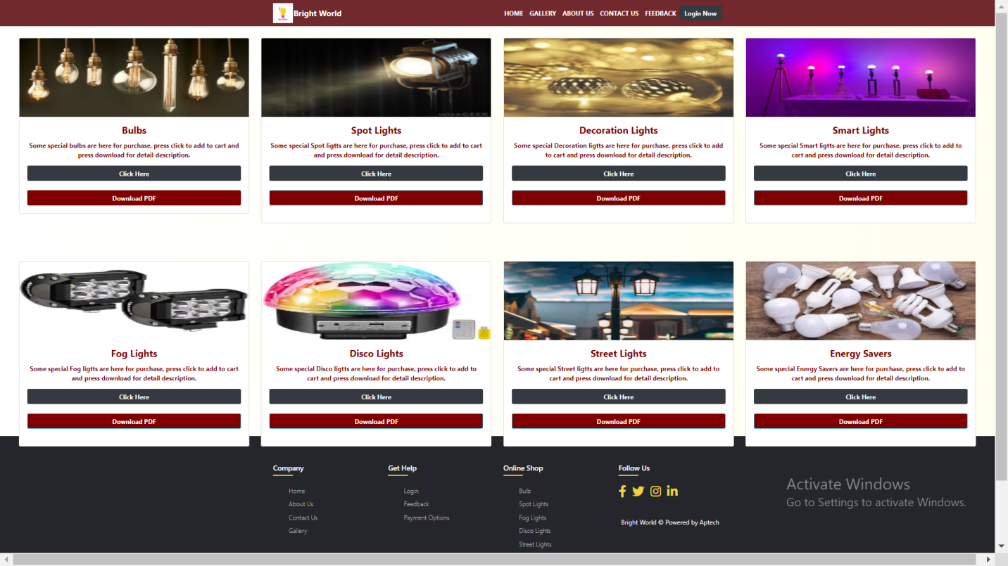

**Login and Registration Section**

* User now login to Bright World.

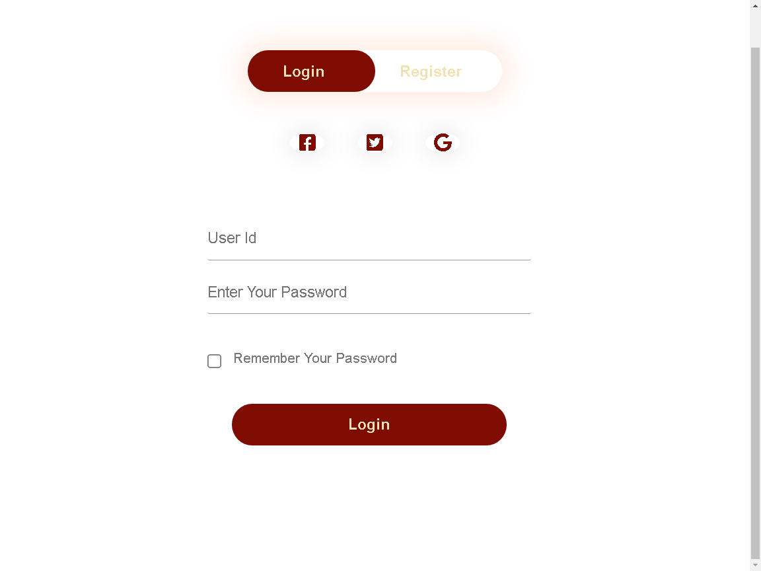

**Registration Section**

* If user is login our web site first time, registration needed.

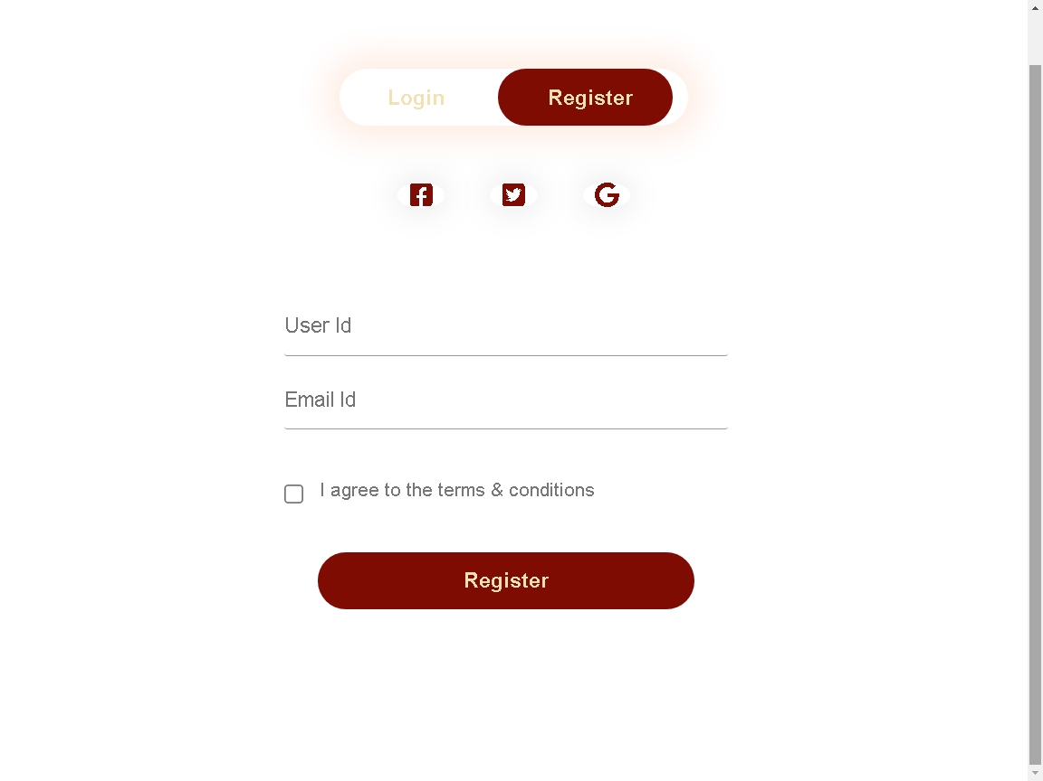

Multiple Category Section

* Now user will go to category section for buy online by clicking on

**“Buy Online”** button.

* User can collect many products as desire by clicking on “**Add to cart”** button.

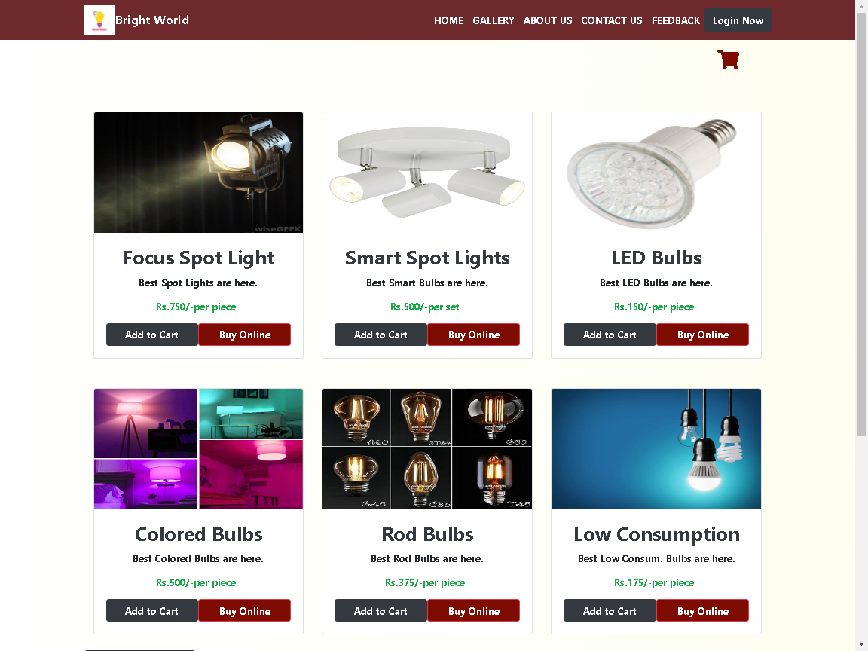

**Contact us Section**

* User can contact us for further details.
* User has the facility of Google Maps Service

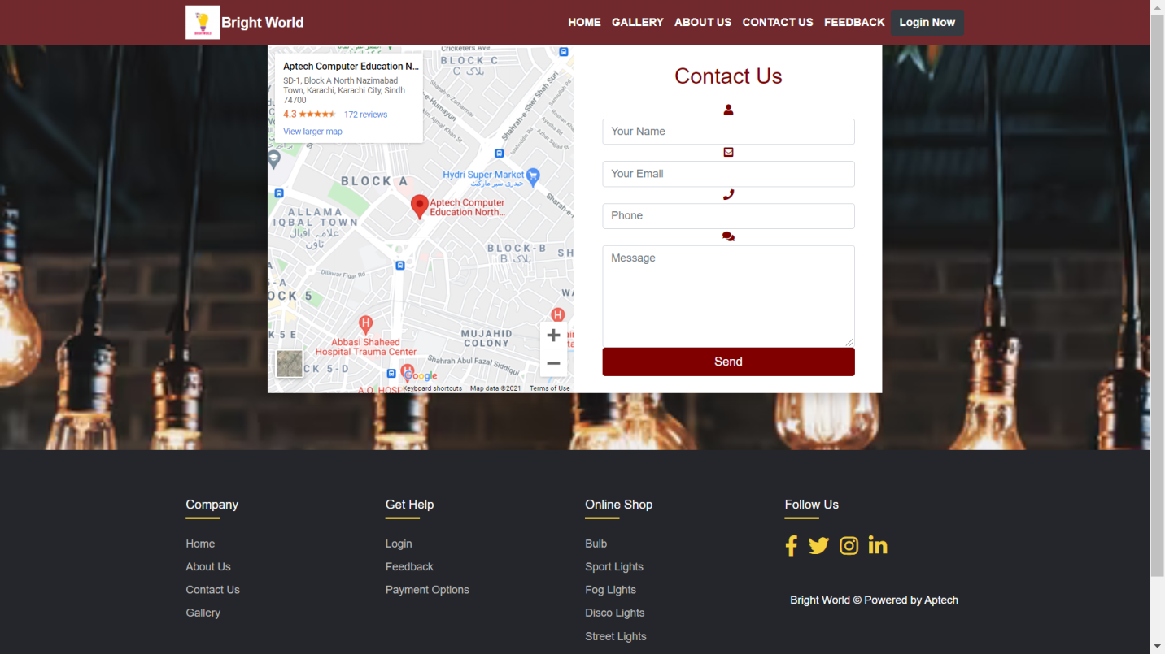

**Feedback and Comment Section**

* User can drop feedback, also tell us about the problems
* User also can give comments about this website.
* We resolve the problems during using the website.
* User can give comment about team member of this website.

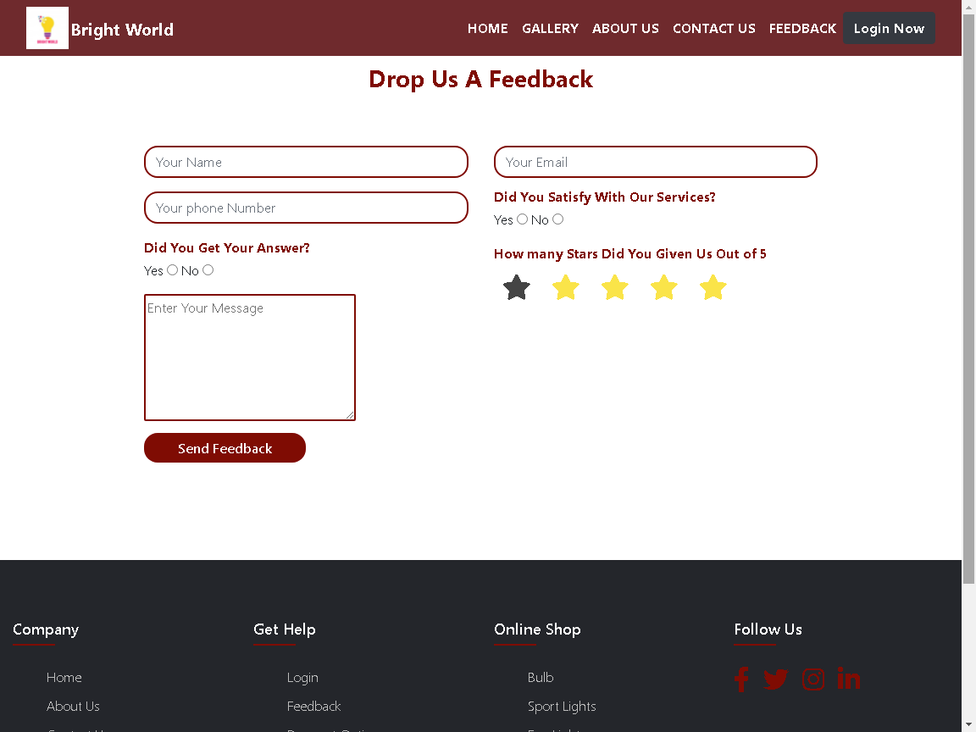

**Footer Section**

* User can access Footer section for quick links at every page about different.
* User can also contact us on world famous apps. (i.e. facebook, twitter etc.)

